**Project Name:** Movie Recommendation System

**Github Link:** https://github.com/projectsforstudents2022/Movie_Recommendation_System.git

**Why was this project created?**

A recommender system is a straightforward algorithm whose goal is to find patterns in a dataset and present the user with the most pertinent information. The algorithm ranks the objects and displays to the user those that it believes are worthy of high ratings. Movie recommendation systems assist us in finding our favorite movies among all of these many movie genres and so ease the burden of hunting for our favorite movies for a long time. We need a highly trustworthy recommendation system that gives us the suggestions for movies that are the same as or most similar to our preferences.

**What problem is it solving?**

The goal of this project is to give people reliable movie suggestions. The project's objective is to make movie recommendation systems better than pure techniques in terms of accuracy, quality, and scalability. By combining content-based filtering and collaborative filtering, a hybrid strategy is used to accomplish this.

**Entire explanation of project**

* **PROPOSED APPROACH**

A recommendation system gathers information on a user's implicit or explicit preferences for various products, such as movies. The user's behavior while watching the movies is used as an implicit acquisition in the creation of movie recommendation systems. The user's past ratings or history are used explicitly in the creation of movie recommendation systems, on the other hand. Clustering is another auxiliary method utilized in the creation of a recommendation system. The method of clustering involves grouping a collection of things so that they are more similar to one another than to those in other clusters. On the movie lens dataset, KMeans Clustering and K-Nearest Neighbor are applied in order to produce the best-optimized outcome.

While in the suggested technique, data is acquired and leads to a lower number of clusters, the data is distributed and produces a high number of clusters. The suggested scheme optimizes the movie recommendation process. The suggested recommender system makes predictions about the user's preferred movie based on a variety of factors. The idea behind the recommender system is that people share similar preferences or choices. The opinions of these users will be influenced by one another. This method optimizes the method and reduces RMSE.

Algorithm for creating next word prediction model :

**Step 1:** Import Libraries & Load Dataset

**Step 2:** Data Preprocessing

**Step 3:** Label Encoding

**Step 4:** Build Neural Network

**Step 5:** Train Model

**Step 6:** Testing & Visualization

* **DATA FLOW DIAGRAM**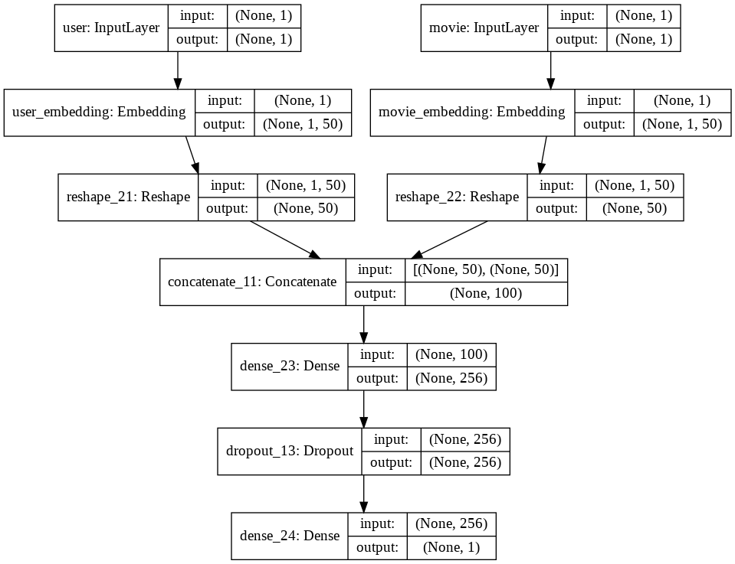
* **RESULT**

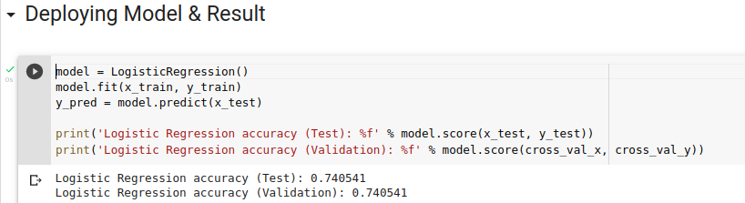

* **CONCLUSION**

In this research, a hybrid strategy combining content-based filtering and collaborative filtering, using Singular Value Decomposition as a classifier and Cosine Similarity as the recommended technique, is provided to increase the accuracy, quality, and scalability of the movie recommendation system. On three separate movie datasets, existing pure methodologies and the hybrid approach are put into practise, and the outcomes are compared.